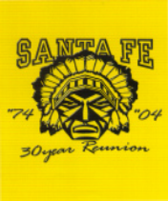
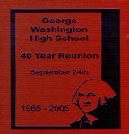
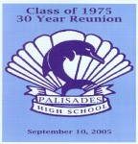

Reunionmanager.net / photos@reunionmanager.net P: (714) 265 3638 F: (714) 265 0121

Dear Reunion Committee:

Thank you for choosing Reunion Manager to help manage your Alumni and Reunion Ticket sales. As part of our service we are pleased to work with REUNION PHOTOG- RAPHERS Inc. a professional reunion photography company with over 30 years experi­ ence for your upcoming reunion.

Please review the enclosed materials that will assist you in the early stages of preparing for your event.

This package also contains PHOTO REMINDER CARDS to hand out to each classmate as they check in the night of the reunion. This card is to help ensure that they each Alumni attending has their photo taken for the memory book. There is no charge for this picture.

The Memory book, Class Group Photo, and the Candid CD (which contains all of the can­ did photos taken that night) can be purchased by Alumni from within their Reunion Man­ ager account and is always available even from previous years.
.
After the reunion, you will be able to access your Reunion Manger webpage and post a Committee Letter and an In Memory page for your Reunion Memory book. We will as­ semble the memory book and post the proof to your Reunion Manager Control Panel for your approval before we print it and send it to the classmates.
Don’t hesitate to call us if there are any questions. Here’s to a FUN Reunion!!

REUNION PHOTOGRAPHERS Inc.

FORM #025 A

CLASS GROUP PHOTO

Our Group Photographer will be taking a Class Group Photo about 20 minutes before dinner. Your help in preparing for this photo will make this an easy, fun affair.

Depending on the class size, we may take two photos to ensure that all classmates are visible in the picture.

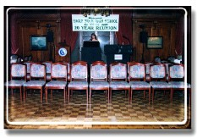
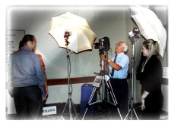
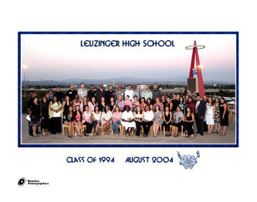
Important:

*Arrange with the hotel beforehand to have 2 rows of 20 (40 total) chairs put onto the dance floor or location where the group photo will be shot. Arrange them so that the first row is facing outward, with the second row back to back of the first row (see example.)

Shortly before dinner, the photographer will co­ ordinate with the committee to have the photo taken. The DJ or Emcee will call up the class­ mates by last name (usually, classmates are called up by the first letter of their last name A-L and then M­Z for two photos, depending on the class size). The photographer and assistant will set up the classmates on the chairs for optimum visibility.

The class Group photo is offered in an 11”x14” size, bordered in the school colors with the school mascot added.

Your help with this photo is greatly appreciated!!!!

Example of how to arrange chairs

Class Group Photo

Your reunion date is fast approaching and, therefore, some consideration needs to be given to the following areas.

Please assign someone on your committee to assist us during the reunion evening as our contact. The in­ formation regarding “Candid Photography” and “Space for the Photographers” is vitally important so everything can start off on the right foot.

We will continue to be in touch with you right up to the week of your reunion. We will call you to confirm the total number of people you expect to attend and to be sure no changes have occurred in your starting time and location.

Please contact us if you have any questions. Fun times are around the corner!

PORTRAIT & CANDID PHOTOGRAPHY
SPACE FOR PHOTOGRAPHERS AT YOUR REUNION

We would like to enlist your aid for obtaining the proper space needed for our photography activities on your Reunion night. Discussion by you with the catering manager or restaurant manager will insure good results. The caterer or restaurant needs to plan space for our location nearest to where your reception desk will be located. A space eight (8) feet wide and twelve (12) feet deep is the minimum the camera crew can work within.

CANDID PHOTOGRAPHY AT YOUR REUNION

While Reunion Photographers is going to be taking approximately eighty (80) color candid pictures of you and your classmates for the Memory Book, we suggest that someone else also be taking pictures as a back up. Our photography is usually completed by 9:00 pm. Pictures taken later in the evening by the committee can be some of the funniest and add considerably to your Memory Book and can be added to the memory book. Also, there may be pictures before the reunion night or possibly at some activity the next day you would like to have in your book.

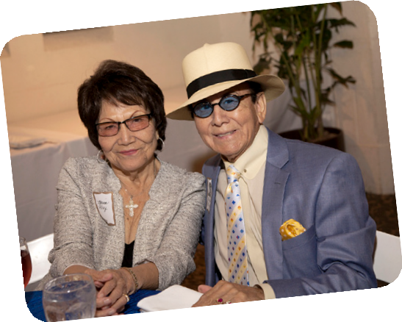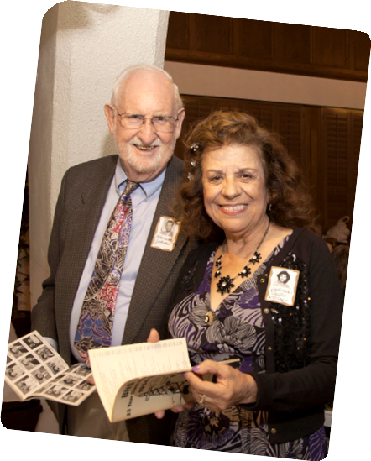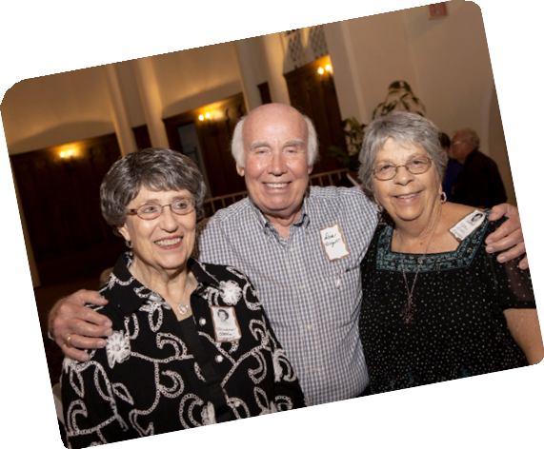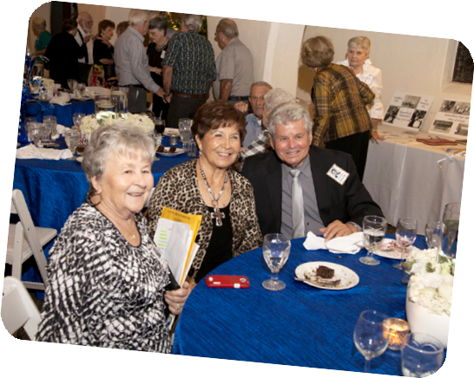

HINTS FOR SMOOTH OPERATION OF YOUR REUNION RECEPTION DESK

Have your reception check-in table ready for early arrivals. Plan to have your reception table up and ready to check­in people about half an hour before your arrival start time. Anyone you can check­in early keeps lines from backing up longer later on. It is also nice to have a welcoming group of classmates already checked­ in to greet the following arrivals.

Do whatever you can as a committee to not be involved in the reception check-in procedures. This is your reunion and now is the time to enjoy it.

The PHOTO REMINDER CARD should be handed out at your reception desk as classmates check in.

For each classmate, place their class group order form, meal ticket and their PHOTO REMINDER CARD inside this envelope along with any other items you may want to include. Alphabetize these envelopes by the classmate’s last name at the time of graduation. Divide all of these alphabetized envelopes into four groups:

A ­ F
G ­ L
M ­ R
S ­ Z
Place those groups into four different shoe boxes with a letter tab showing each letter of that alphabet group.

Please instruct your reception desk people to ask that no badges be put on until after they are photo- graphed. Taking off and putting back on badges only slows down the photography process. Have your reception desk direct the classmates and their guests to the location of photography after checking in.

MEMORABILIA TO DISPLAY AT YOUR REUNION

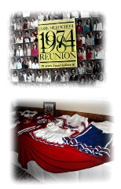
SCHOOL NEWSPAPERS YEARBOOKS (ALL FOUR YEARS) JR. HIGH YEARBOOK
JR. HIGH GROUP CLASS PHOTOS
PICTURES OF CLASSMATES DURING FOUR YEARS LETTERMAN SWEATERS
PEP SQUAD UNIFORMS/BAND UNIFORMS/INSTRUMENTS
MEGAPHONES
SPECIAL SHOES OF ERA CLOTHES OF ERA
OLD PORTABLE RADIOS SCHOOL BOOKS SCHOOL RINGS
OLD CAMERAS AND FLASH BULBS ROOM PASSES
RESTAURANT MENU
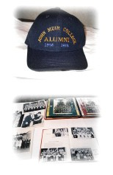
SPORTS PROGRAMS, FOOTBALL JERSEYS, HELMETS AREA NEWSPAPER CLIPPINGS
OLD MOVIE POSTERS (OF ERA)
OLD AUTOMOBILES (PICTURES AND REAL CARS) DRAFT CARD
RECORDS (78 RPM, 45 RPM, 33 RPM) WIND­UP PORTABLE RECORD PLAYER SCHOOL PLAY PROGRAMS
PICTURE OF SCHOOL MASCOT STUDENT BODY CARD
OLD ADVERTISEMENTS WITH NEWSPAPERS GRADE SCHOOL GROUP PHOTOS HOMECOMING PICTURES
SENIOR SNEAK, DITCH, ETC. DAY PHOTOS SENIOR PROM DANCE PHOTOS
GRAD HAT TASSEL HIGH SCHOOL DIPLOMA

AFTER YOUR REUNION

To help streamline the Memory Book process you will find within your Reunion Man- ager Control Panel under:

Tab 2 – Events/Photos

You will see all information related to REUNION PHOTOGRAPHERS.

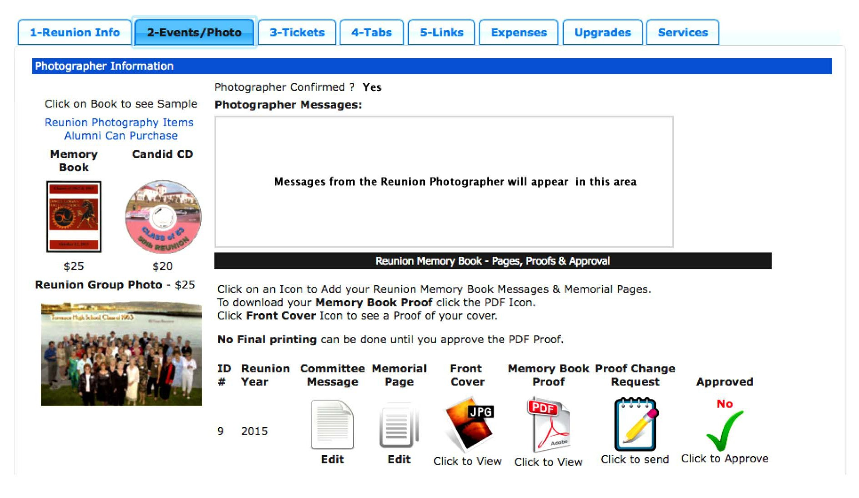

From within this section you can submit your Reunion Committee Message and include all Memorial Information you wish. These are not mandatory but most Reunions we have worked within the past like to include both when possible.

Once your draft Memory Book is ready we will upload it to your Control Panel for review to this section and notify you via email. You can view the PDF Proof and inform us of any changes you would like us to make. Once the Digital Proof is ready you can approve it on line and we will print the books send them to your classmates. We can not send any Memory Books out until you approve it.

